String Operations in Python

1. Find the length of the string   
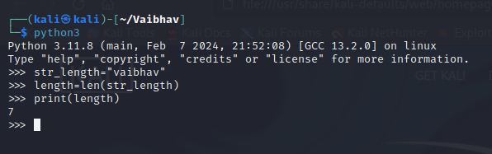

2. Slice the string as per your choice   
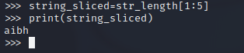

3. Concatenate two strings   
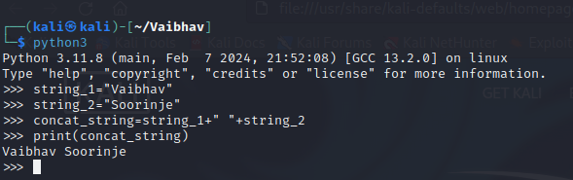

4. Convert in to lower case in to uppercase character   
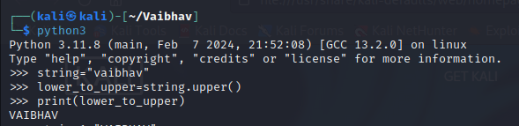

5. Convert upper case into lower case characters  
  
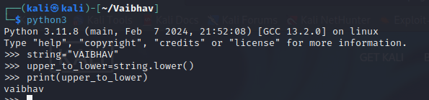

6. convert the character into Unicode ( Ascii values)  
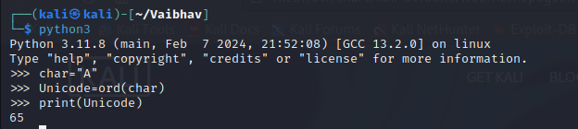

7. convert Unicode into character   
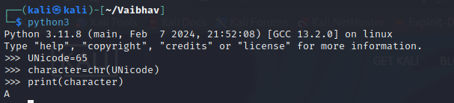

8. Check whether the given "substring" exists in the string  
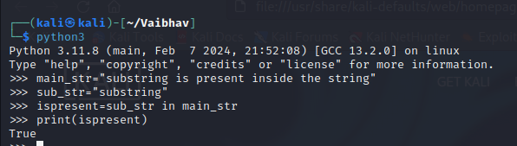

9. Replace the character 'k' with 'h'  
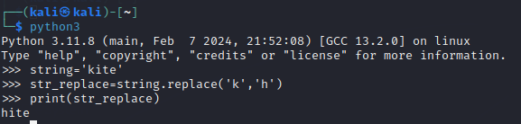

10. Pad the string with "x" at the end  
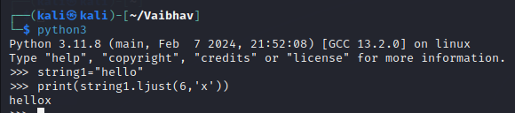

11. remove leading and trailing whitespace or specified characters from the string  
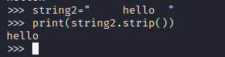

12. split the given string in to group of five characters

13. count total number of words

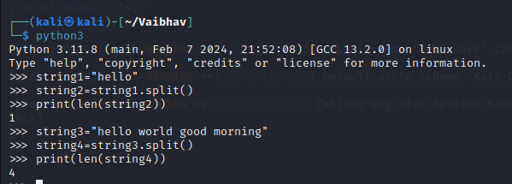

14. Find the frequency of each characters in the string

STDIN and File operators

15. get the file name from the user   
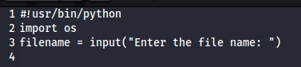

16. check the file exist or not   
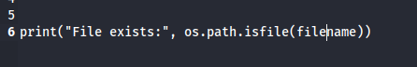

Looping and File handling

17. read the contents from the file   
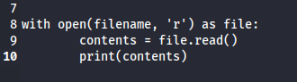

18. reverse the contents from the file   
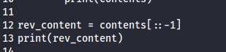

19. Write into the file

  
  
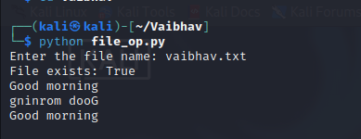

Math operations

20. convert Frequency in to percentage (continuation of 12th Question)   
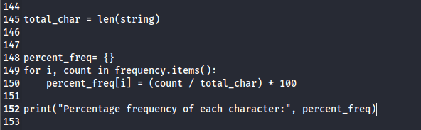

21. Perform modular arithmetic operation   
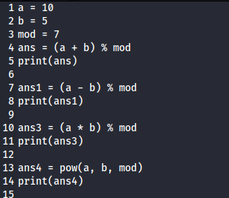

22. Find the prime numbers

check the given number is prime or not

print the prime numbers with the given range   
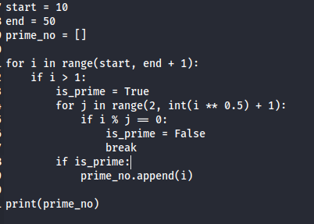

23. Check the given two numbers are co prime or not

24. find the factors for the given number ( can use python library)

25. generate 10 random numbers

26. Explore : Miller-Rabin Test (pen paper method)

“Don’t worry about failures, worry about the chances you miss when you don’t even try.”

– JACK CANFIELD